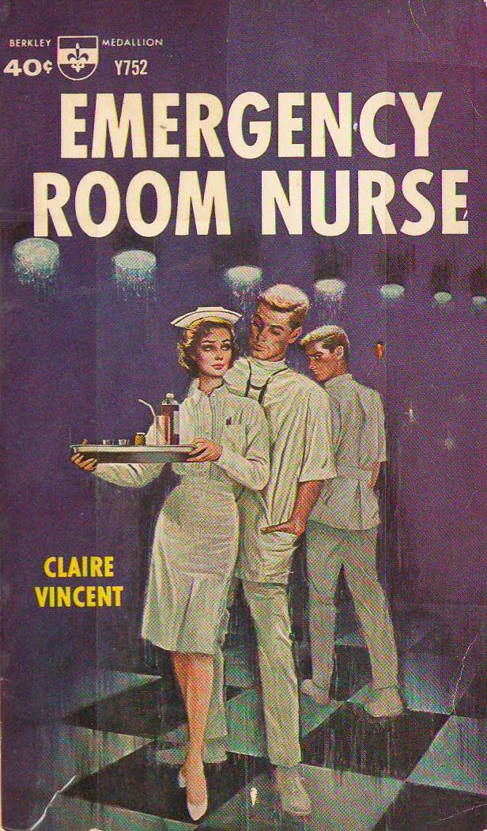

“A day in the Life of an Emergency Nurse”

Is it really that glamorous? (no)
  - Is it the best nursing job ever? (yes!)

Discussion with emergency nurses with varying years of experience from all over East Texas.
Hear about their days, successes, challenges, frustrations, and thrills.
A question & answer session will be held afterwards.
Tim Hernandez, BSN, RN - CHI St. Luke’s Memorial in Lufkin
Lee Walker, CHRISTUS Trinity Mother Francis
Manny Pereira, Hospitality Health ER in Longview
Mary Suits, Longview Regional Medical Center ER in Longview
China Jackson, CHRISTUS Good Shepherd ER in Longview
Trace Hudgins,
…and your Master of Ceremonies: Karyn Smith, President-Elect ETENA
Who should attend?
Student nurses and new nurse graduates
Nurses who are interested in moving to the ED
Emergency nurses who want to hear if the grass is greener at other facilities!

Thursday 9/3 @ 7:30pm
Virtual meeting

Register at www.easttexasena.org to receive Zoom link
Or contact kcourville@uttyler.edu

This event is brought to you by the
East Texas Emergency Nurses Association

